**Experiment #11**

**OBJECTIVE:**

To become familiar with array as a member of structure.

**Structure:**

**Structure i**s a collection of variables of different data types under a single name. It may contain similar or different data types

**Declaration:**

struct Structure_name

{

Data_Type1 Identifier1;

Data_Type2 Identifier2;

.

.

.

};

**Accessing Members of structure:**

**Syntax**

Struct_Var.Mem_Var;

**Program# 01**

#include <iostream.h>

#include <conio.h>

struct student

{

char name[50];

int roll;

float marks;

};

int main()

{

student s;

cout << "Enter information," << endl;

cout << "Enter name: ";

cin >> s.name;

cout << "Enter roll number: ";

cin >> s.roll;

cout << "Enter marks: ";

cin >> s.marks;

cout << "\nDisplaying Information," << endl;

cout << "Name: " << s.name << endl;

cout << "Roll: " << s.roll << endl;

cout << "Marks: " << s.marks << endl;

return 0;

}

**OUTPUT:**

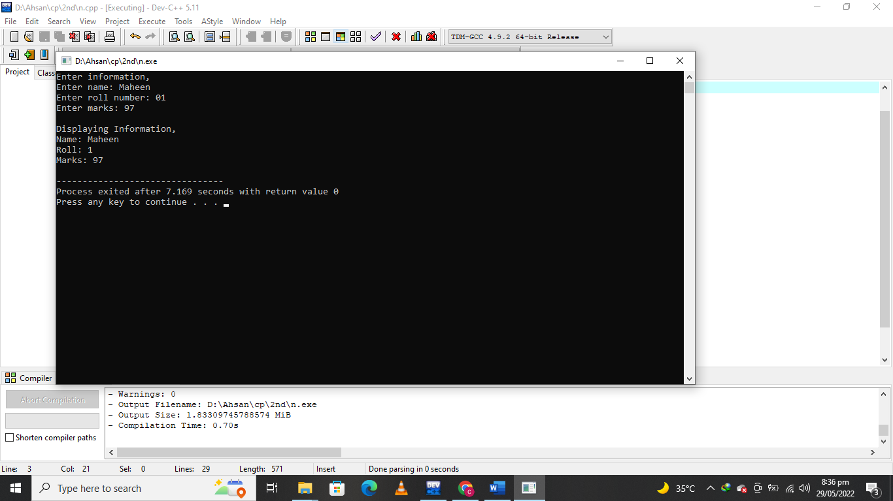

**Array as a member of structure:**

A structure may consist of difference type of data. The member variable can be simple data type such as int char and float. The member variable can also be complex like **array.**

**Example:**

**struct Student**

**{**

**int rollno;**

**int Marks[5];**

**};**

**Program#02**

#include<iostream.h>

#include<conio.h>

struct Employee

{

int Id;

char Name[25];

int Age;

long Salary;

};

void main()

{

int i;

Employee Emp[ 3 ]; //Statement 1

for(i=0;i<3;i++)

{

cout << "\nEnter details of " << i+1 << " Employee";

cout << "\n\tEnter Employee Id : ";

cin >> Emp[i].Id;

cout << "\n\tEnter Employee Name : ";

cin >> Emp[i].Name;

cout << "\n\tEnter Employee Age : ";

cin >> Emp[i].Age;

cout << "\n\tEnter Employee Salary : ";

cin >> Emp[i].Salary;

}

cout << "\nDetails of Employees";

for(i=0;i<3;i++)

cout << "\n"<< Emp[i].Id <<"\t"<< Emp[i].Name <<"\t"

<< Emp[i].Age <<"\t"<< Emp[i].Salary;

}

**OUTPUT:**

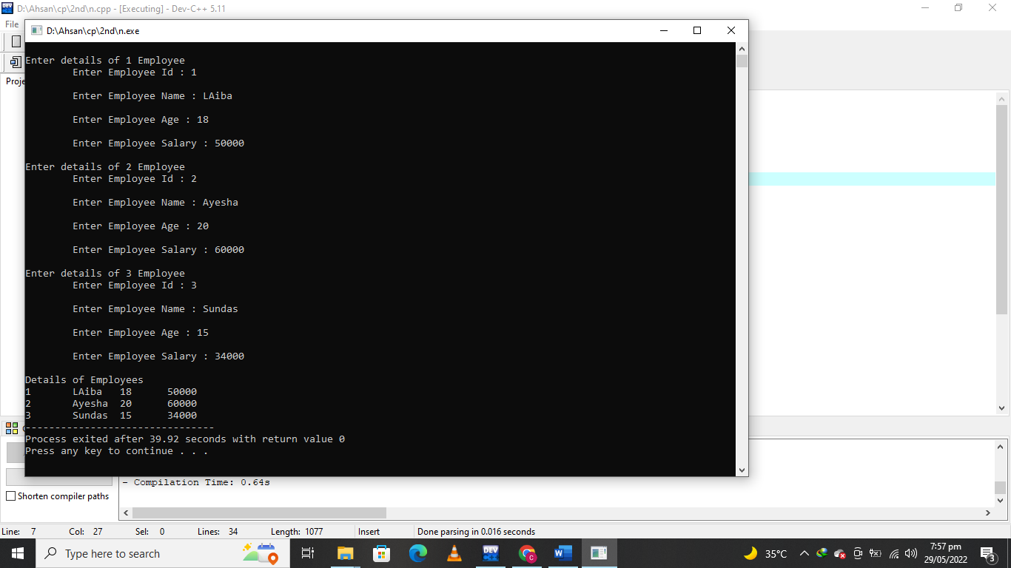

**Lab Tasks:**

QNo:01 Compile and execute the above codes and display the outputs.

QNo:02 Develop the C++ code to demonstrate the concept of array as a member of structure?

**QUESTION NUMBER : 01:**

Compile and execute the above codes and display the outputs.

**ANSWER:**

You can find you Answer in above Examples .

**QUESTION NUMBER : 02:**

Develop the C++ code to demonstrate the concept of array as a member of structure?

**PROGRAM:**

#include <iostream>

#include <cstring>

using namespace std;

struct student

{

int roll_no;

string name;

};

int main(){

struct student stud[5];

int i;

for(i=0; i<5; i++){

cout << "Student " << i + 1 << endl;

cout << "Enter roll no" << endl;

cin >> stud[i].roll_no;

cout << "Enter name" << endl;

cin >> stud[i].name;

}

for(i=0; i<5; i++){

cout << "Student " << i + 1 << endl;

cout << "Roll no : " << stud[i].roll_no << endl;

cout << "Name : " << stud[i].name << endl;

}

return 0;

}

**OUTPUT:**

